

**METRO Slovakia Customer Profitability Tool**

**Statement of Work**

|  |  |
| --- | --- |
| **Adopted date** | Dec 1 2021 |
| **Version** | 1.0 |
| **Confidentiality Classification** | Restricted |
| **Owner** | METRO Business Solution Center (BSC) |
| **Customer** | METRO Slovakia |
| **Project Name** | Customer Profitability Tool |

Contents

1. Background & Purpose: 3

2. Project Description & Scope 3

2.1 Scope 3

2.2 Web Application Development 4

2.1.1 Development Scope 4

2.1.2 Maintenance Scope 8

2.3 Scope exclusions 9

2.4 Change Request 9

3. Technologies & Application Landscape 10

3.1 Technologies 10

3.2 Application Landscape 10

4. Security & Compliance 10

5. Assumptions, Risks and Customer dependencies 11

5.1 CUSTOMER Responsibilities 11

5.2 Project Governance structure 12

5.3 Assumptions/Risks 12

6. Estimated timeline 12

7. Commercials 13

7.1 Charging model 13

7.2 Payment Terms 13

8. Termination 14

9. Order of Precedence 15

**METRO Slovakia Customer Profitability Tool - Statement of Work**

This Statement of Work, dated 01st October 2021, (“SOW”), is pursuant to the METRO Slovakia Service Agreement, dated xxth xxx 20xx in combination with appendix 3.15 “METRO Business Solution Center (BSC)” - Services (former “Continuous Process Improvement and Automation”). dated xxst xxxxxx 20xx.

All the terms and conditions in the above stated SLA and the respective appendix are applicable to this SOW. In case of any conflict between this SOW and the SLA/ Appendix, the terms of the SLA/ Appendix shall prevail unless stated otherwise in this SOW.

Any proposed changes to the terms of the services set forth in this SOW shall become effective only upon a mutually agreed to written amendment hereto.

# 1. Background & Purpose:

Customer aims to increase the profitability from customers. In order to do that the sales force needs to know what is the Percentage Overall Total Income (OTI%) that they get from the customer, they are working with. Ideally the sales force negotiates with the customers to manage and vary the prices of selected articles and see what is the OTI%. As-is, a VBA based MS Excel solution is being used, to do the same. However, there are limitations like solution being less user friendly, unable to hide confidential data, need to be shared with huge data that needs to be a part of the solution

The proposed solution aims to address the issues present in the existing solution and provide a user friendly, scalable, dynamic web-based application with scope for further feature additions in future

# 2. Project Description & Scope

## 2.1 Scope

The proposed solution will be developed using

* **PHP** *[Hypertext Preprocessor (PHP) is known as a general-purpose scripting language that can be used to develop dynamic and interactive websites]* for the front-end web development and
* **SQL** *[Structured Query Language (SQL) is the standard language for dealing with Relational Databases. SQL can be used to insert, search, update, and delete database records]* based querying for the data engineering in the back-end part.
* The scope of the solution component to be called as **Gen 1 / Version 1** is as follows:

## 2.2 Web Application Development

### 2.1.1 Development Scope

* The web app will comprise of **4 pages ( 3 pages accessible for all users + 1 page for specific users)**
  + - 1. **Page 1**: Login page with IDAM integration – Users can use their METRO id and passwords to login. This will be in compliant with the METRO standards
      2. **Page 2**: Home page where the users can select the data to transfer to the offer list. This page will consist of
    - **INPUTS**
    - **Customer HO number** (Customer table – ico) that will be linked to the Customer number. The user will have an option to select the HO number from a list or type and search for the same
    - Once the customer HO number is selected, the **linked customer numbers** (Sales table - cust_no_unique) will be displayed in a separate list and users can select the required customer number, there will be option to include all listed customer numbers as selection
    - **Article Category:** The second filter is article category to choose the category of the article (Dry, Non-Food, Fresh, Ultra fresh) from the dropdown (article table "catmanager_group"), there will be option to include all listed article categories as selection
    - **Channel type:** Another dropdown to select the type of channel as Cash & Carry, FSD and both
    - **Date and Time Range:** A calendar (with from and to dates) to select the range of data to be filtered. Data to be filtered (Sales table - f_date_of_day or f_month_id)
    - **Download Data / Show Data:** Once the required options in the filters are selected, the user can have an overview of the data once they click on the “Download Data” or “Show Data” button
    - **DATA SUMMARY**
    - Once the user clicks on the Download data or Show Data button, the following details are shown in the form of tables
    - **Sales History & Trend Table:** the sales overview of the customer (Total Sales, Total OTI%, Invoices per month) excluding data related to Cigarettes and Petrol sales – have quarter view with option of selecting separate quarters

|  |  |  |  |  |  |
| --- | --- | --- | --- | --- | --- |
| Financial Quarters will be manually chosen by end user, with multiple choices possible | | | | | |
|  |  |  |  |  |  |
|  |  | Total Sales | Total OTI % | Invoices/period |  |
|  | **Last month** |  |  |  |  |
|  | **Q1** |  |  |  |  |
|  | **Q2** |  |  |  |  |
|  | **Q3** |  |  |  |  |
|  | **Q4** |  |  |  |  |

* + - * Total Sales = Sum of "sales” from Sales Table
      * Total OTI % = Average of “oti” divided by “sales” as per the time window
      * Invoices / month = Count of “invoice_id” and divide by 3/6/12 as per the number of months
    - **Category Sales Share:** Thistable will show what is the category sales share of the customer for the selected time period. This will show the sales share in terms of Ultra fresh %, Fresh %, Dry % and Non-Food %. The sum of these will always be 100%

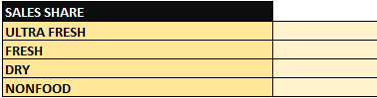

* + - **Customer Purchase data:** A table showing selected columns from tables
      * svkccp_fls.F_Sales_v2 – Sales table
      * svkccp_fls.D_Customer_v2 – Customer table
      * svkccp_fls.D_Article_v2 – Article table
      * svkccp_fls.D_Store_v2
      * svkccp_fls.D_Time_v2
      * svkccp_fls.D_SF_Advisor_v2
      * svkccp_fls.KBL_D_Article_NNNBP
    - NOTE: The article master table needs to be refreshed every day and other tables every month
    - NOTE: For NNNBP, there are 3 types. The selection of the nnnbp will be as per the Buyer UID (example, nnnbp_current_cc for BF001). More details mentioned under the section **2.1.1.4** **Page 4**
      * nnnbp_current_cc
      * nnnbp_mav_cc
      * nnnbp_reg_cc

50 rows will be displayed at a time with option to move to next 50 and so on. These columns of the table will have – optional to choose from select 50,150 or 200 and than move to other list

* + - * Search options (Free text field) to search required data
      * Filter option – To select required domain
      * 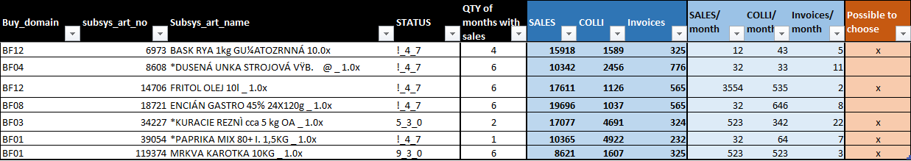Sort options – Main category / Buy domain
        + Buying domain = "buy_domain" from Article table
        + Subsystem Article number = "subsys_art_no" from Article table
        + Subsystem Article name = "subsys_art_name" from Article table
        + Status = "status_article" from Article table
        + Quantity of months with sales = count of "subsys_art_name" or "subsys_art_no" from Article table for the selected time period /
        + Sales = Sum of “sales” grouped article wise
        + Colli = Sum of “colli” grouped article wise
        + Invoices = Count of “invoice_id” grouped article wise
        + Sales / month = Sales / Quantity of months with sales – quarter(AVG) as per the selected quarters
        + Colli / month = Colli / Quantity of months with sales - as per the selected quarters
        + Invoices / month = Invoices / Quantity of months with sales -quarter(AVG) as per the selected quarters
      * The buying domain will domain to be specified in actual name rather than the Buy_domain ID used here
      * This table will have the option to select required rows via a checklist in the left side of the table across each line item / rows
    - **Go to Offer list:** Once the required rows are selected the user can click on the “Go to Offer list” button to move to the next page
      1. **Page 3:** **Forecasted OTI calculation screen.** The user inputs the price and quantity of the articles selected and calculates the forecasted OTI%.
* This page will carry forward the line items / rows selected from the previous page
* Items which are not part of FSD assortment will be highlighted
* Items which have been delisted will be highlighted in red and shall not accept data
* Each selected articles / rows will have 2 input fields, which will be entered by the user (Sales Rep) during the discussion with the customer
  + Price
  + Colli
* Options will be provided to add more rows manually in the form of a “+” button, in case the customer wishes to purchase a new item/article
* **Backbonus Logic**
  + 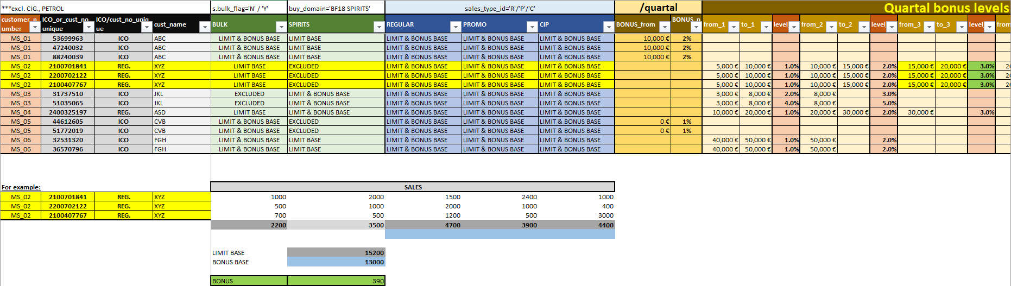In the same page below the articles field, there will be a separate area exclusively for back bonus logic calculation, as per the excel reference provided in the below snapshot
  + A dropdown to select multiple HO numbers and multiple customers linked to those HO numbers
  + For the selected customer or multiple customers ids linked to one HO number, the user will have options in dropdown to select the bonus type
    - Limit Base
    - Limit & Bonus Base
    - Excluded
  + The dropdown with all the 3 options should be visible for the columns “BULK” (s.bulk_flag= “N”/”Y”), “SPIRITS” (buy_domain=”BF18 SPIRITS”), “REGULAR”, “PROMO”, “CIP” (sales_type_id=”R”/”P”/”C”)
  + In case of multiple customers linked to a HO number, the user can have only one combination of the bonus types. i.e, All the customer ids linked to an HO number should have the same types of bonus rules selected for Bulk, Spirits, Regular, Promo and CIP. An error message conveying the same message should be displayed even if the user selects otherwise
  + The user will also have the option to define the amount and % backbonus. This is an open text field and there will be 2 types of inputs. But only one type will be taken into consideration for calculation.
    - **Type 1:** User enters only the minimum amount (BONUS_from) and the bonus percentage – “Level 0” or “General Level”
    - **Type 2:** User has option to define 5 levels of bonus in ranges (from_x to to_x, where x= level of the bonus). **For example**, for the selected customers, user can define the bonus as below
      * **Level 1 :** From €5,000 to €10,000. Bonus = 1%
      * **Level 2 :** From €10,001 to €15,000. Bonus = 2%
      * **Level 3 :** From €15,001 to €20,000. Bonus = 3%
      * **Level 4 :** From €20,001 to €25,000. Bonus = 3.5%
      * **Level 5 :** From €25,001 to €30,000. Bonus = 4%
    - If the user provides type 1 input, type 2 should be disabled and if type 2 inputs are provided, type 1 is disabled
  + The levels, bonus and ranges will be defined by the user on a case-by-case basis depending on the customer
  + Finally, the Limit base is calculated by taking the sum of all sales numbers **(Forecast entered in the colli and quantity fields by the sales representative)** that has either “Limit base” or “Limit & Bonus base” selected. This will be the basis for selecting the bonus % from the different levels.
    - For example, if the Limit base total is €27,400, then, form above example, the bonus will be 4%
  + Bonus base is calculated by taking the sum of all sales numbers that has “Limit & bonus base” selected. This will be the basis for calculating the Backbonus
    - Backbonus = Bonus base * Selected bonus %
    - In above example, if Bonus base = €20,000, then Backbonus = €20,000*4% = €500
  + The sales numbers for which “Excluded” was selected are no taken into consideration for calculation
  + The entries for different levels, backbonus applied needs to be stored in the backend for future reporting
* Once all the inputs are provided, the user can click on the “Calculate Forecasted OTI%” to get to know the OTI% for the price and colli combinations entered. The value is displayed based on the logic for OTI% calculation and formatted as per conditions listed below,
* Forecasted OTI % of the basket = [sum(Colli*selling price) - sum(Colli*nnnbp) - back bonus] / [sum(Colli*selling price)]
* Historical OTI% = Average OTI% of the customer (OTI% = OTI absolute (from the table) / sales absolute) as per the selected quarter
  + NOTE: The nnnnbp should be as per the assigned nnnbp type (nnnbp_mav_cc / nnnbp_reg_cc / nnnbp_current_cc)
* The Sales rep is allowed to reduce a 5%p from the Historical OTI% of the customer. OTI Investment % should be less than 5% (or greater than -5%) compared to previous year/ previous 2 quarters (AVG selected quarters). So, Forecasted OTI% - Historical OTI % should always be less than or equal to 5%*.* If the difference is greater than 5% highlight via an alert pop up
* Minimum OTI per article should always be > 0. If the OTI of the article is less than 0, highlight the line item/ row in red
* Percentage Sales increase compared to previous year should be greater than 25%. Show an alert message if the condition is not met
* Absolute sales increase compared to previous year should be greater than 20,000 (EUR). Show an alert message if the condition is not met
* Percentage change in OTI compared to the previous year should be greater than 50% of Percentage change in sales compared to previous year
  + - 1. **Page 4:** **NNNBP Update screen.**

This view is applicable for only select users. The purpose of this page is to assign the type of nnnbp to the Buyer UID so that during OTIF calculation, the application picks up correct nnnbp for the relevant Buyer UID

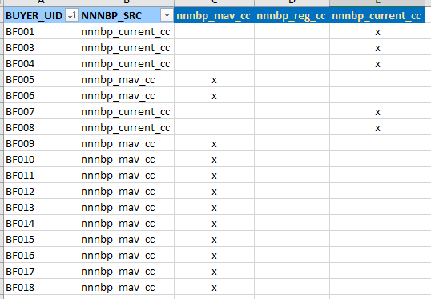

* The select users should have visibility to this page. In this page, all the Buyer UID should be listed in rows and the 3 nnnbp fields should be listed as columns. User should have the option to assign a particular nnnbp to a particular Buyer UID via radio buttons
* This should be only like a „convertor“ of nnnbp. After assigning the nnnbp by selected user, use the input as conditions when calculation OTI%. The nnnbp used during calculation of OTIF% in page 3 should be as per the assigned nnnbp

### 2.1.2 Maintenance Scope

* Web app availability will be 24*5 (24 hours and 5 Working Days Monday to Friday). Maintenance is done with the agreed SLA and only during core hours **12:00 PM - 7:30 PM IST (8:30AM to 4:00 PM CET) Monday to Friday except Indian national holidays**
* If any issue within scope, arises during none-core hours, then the issue will be attended next working day. 10 man hours are dedicated per month for maintenance. Types of issues in in scope of maintenance are as follows -

|  |  |  |  |  |
| --- | --- | --- | --- | --- |
| **Prio #** | **Priority name** | **Description, examples** | **Resolution Time** | **Response time** |
| 1 | P1 | Site down. Server issues | 24Hrs. | 12Hrs. |
| 2 | P2 | Incorrect data flow. Issues in collecting and storing data and cookies. | 3 days. | 12Hrs. |
| 3 | P3 | Wrong outcome due to logic changes | 3 days. | 12Hrs. |

* Regular maintenance and monthly review will be conducted to assess the solution performance.
* **Response Time:** Time to provide RCA
  + After creating any incident if technical team and business will find as new change in RCA then ticket will be diverted to "Change request" category.
  + SLAs and Response time are based only with respect to technical issues, if there are any process related incidents, SLAs will not be applicable in such cases.

## 2.3 Scope exclusions

* During the discussion other possible features were also considered. However, considering the importance of the feature and time availability, these requirements has been agreed to be explored for **future** **versions / Gen 2** and are not in the current scope of the solution development
  + Automatic recommendation of pricing for a given OTI% input
  + To make adjustments in any offer such as CIP, back-bonus (entire sales or regular sales), equipment support, etc.
  + A chance for SaM to estimate quantity growth per CIPed articles and others]
  + Reporting and Dashboard
* Any deviations from the scope and approach stated above would be considered as a change request which shall involve effort and commercial implications. Such work / services shall be executed only after written confirmation and amendment to the SOW by both parties.
* Anything that has not been specifically captured and enumerated as part of the deliverables in this proposal is considered “out of scope”
* Automatic approval process of whether the bonus provided to customers is “OK” or “NOT OK”

## 2.4 Change Request

Changes in work activities which require up to 5 days effort per year are included in the support & maintenance package and any changes that require an effort beyond 5 days per year shall require a mutually agreed Change Order to this SOW. The Customer acknowledges that additional fees may apply. Changes may include, but not be limited to the following:

* Any scope items not listed in this SOW (Sections 2.1, 2.2)
* Investigative work required by BSC to determine the impact of material changes.
* Delays created by Customer’s request to change the schedule requested or caused by Customer’s inability to meet its commitments.
* Delays in dependency realization from third party vendors.
* Extension of the SOW Term, including but not limited to delays caused by a change in previously agreed-upon Deliverables, milestones or other project related items, and Customer’s inability to meets its commitment.
* To manage change properly, changes need to be identified, recorded, assessed, and approved to the Project. BSC’s Business Analyst and Customer’s Project Manager will classify, prioritize, approve, or reject changes. Change requests need to be clearly defined, including cost and schedule implications, to allow BSC management to make appropriate decisions. BSC’s Business Analyst will always need prior authorization and approval of expenditures by Customer’s change control board (Governance Board) before starting work on changes

# 3. Technologies & Application Landscape

## 3.1 Technologies

* Application frontend – PHP
* Application backend – MySQL
* Database – Teradata MDW (Metro Data Warehouse)

## 3.2 Application Landscape

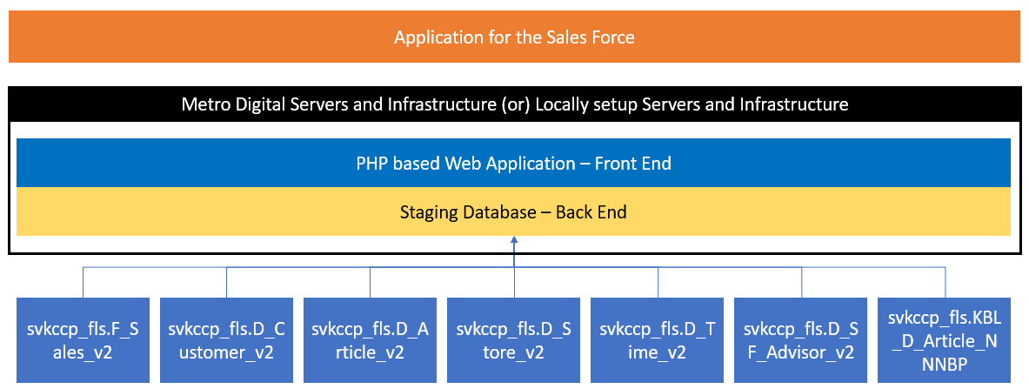

The application will be developed to make it accessible by multiple users at the same time

* Application frontend – PHP is used to design the UI, buttons, forms and text display. METRO Business Solution Center frontend developers are responsible for this part.
* Application backend – A staging data base will be setup to connect from the multiple tables and to accommodate any manual addition of information that comes into the tool
* As per confirmation from customer, IT Readiness is taken care by METRO Business Solution Center wherein all infrastructure components such as Hardware and Operating System, Licensed Database if any, Servers and any other IT components (hardware or software) which are used for solution paid for by CUSTOMER, will be provided by 3rd party (METRO Digital).

# 4. Security & Compliance

* We strictly follow compliance principles for data collection and storing. We will also follow the data protection and IT security policies of METRO. A consent will be taken prior from users to use their data for sales & marketing purposes and to drop cookies.
* Whenever a website is accessible from outside METRO Network, a Load balancer is mandatory because we don’t have a public IP set for our Virtual Machines (VMs) and METRO machines are created with Internal IP address by default. The Web Application Firewall (WAF) in the load balancer protects the application from hackers and includes daily rule updates just like a virus scanner.
* The load balancer can detect and drop distributed denial-of-service (DDoS) traffic before it gets to your website. (Make it broad & implementation)
* Identify fraud/theft --> User credential check – IDAM (Identity Access Management) Integration for all user accessing the solution. IDAM integration to provide a layer of security
* Weak code --> Penetration test
* Human errors --> UAT/Stress test
* Data base overflow --> Server monitoring done by METRO Business Solution Center, wherein METRO Business Solution Center will be using the servers provided by erd party (METRO Digital) reserved specifically for METRO Slovakia

# 5. Assumptions, Risks and Customer dependencies

## 5.1 CUSTOMER Responsibilities

* Solution Build of the web application will be carried out in Pune. CUSTOMER team will review, provide inputs, test and ensure Go Live of the developed solution to success.
* CUSTOMER will assist to develop necessary accurate and complete documents available for explaining these documents / processes whenever required to the implementation team.
* Any deviations from the scope mentioned in this document would be treated as a change request. If a scope change becomes necessary, a CUSTOMER representative needs to submit a formal change request form; the change request will then be assessed by METRO Business Solution Center for its feasibility and potential impact on cost, quality and timeline and share the assessment results with CUSTOMER, post which the CUSTOMER representative can confirm whether to take the change request ahead.
* CUSTOMER’ stakeholders identified for this project would be available as per the project phases and timeline agreed for successful completion of the project.
* If training is required, CUSTOMER will ensure availability of participants for training as per project plan / schedule for the training. All necessary infrastructures for training will be arranged by CUSTOMER.
* All business communication and documentation will be in English language.

CUSTOMER acknowledges that above mentioned CUSTOMER Contribution(s) are integral and important for successful implementation of the Project and any delay on the part of CUSTOMER would affect the Project timelines and cost. CUSTOMER agrees to provide these Contribution(s) for the Project.

## 5.2 Project Governance structure

|  |  |
| --- | --- |
| Committee | Members |
| Governance Team | Zuzana Schoenbeckova, Matej Sklar, Ganesh Tambe, Kristian Scipa, Martin Zahradnik |
| Steering Team | Zuzana Schoenbeckova, Matej Sklar, Abhijeet Singh, Shanmuga Srinivas |
| Development Team | Business Analyst (Shanmuga Srinivas), Web Developer (Sharad Gaikwad), Data Engineering (Kiran Gawade) |

## 5.3 Assumptions/Risks

* For the development of the application, the standard user accounts with 30 days password change condition will be used
* Post development of application, a create special access can be created, where it won’t be necessary for monthly password change. This has dependency on Corporate IT team)
* All the data we are collecting from customers is compliant with METRO and respective country or region policies. CUSTOMER needs to align and ensure all legal formalities.

# 6. Estimated timeline

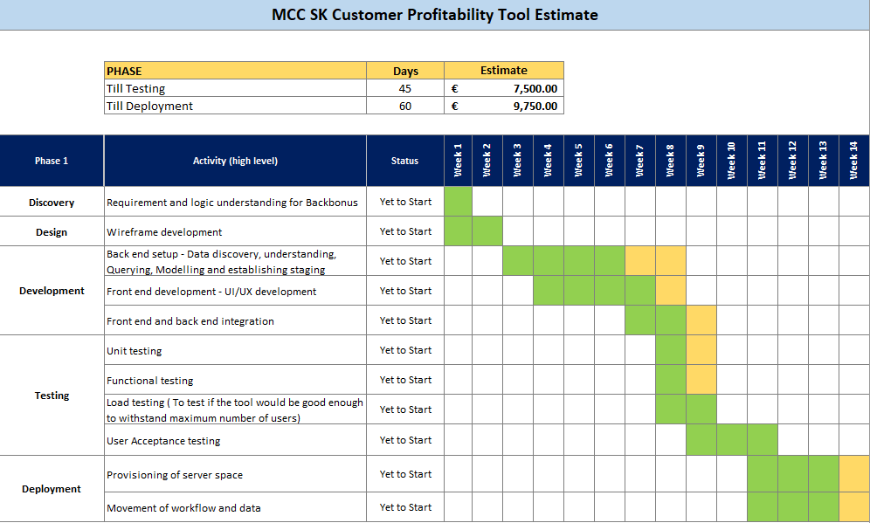Please refer the attached file for more details. All the provided timelines are according to the defined scope, assumptions and development and deployment. Any change in the requirements/scope will affect timeline and commercials.



Attached file for reference

# 7. Commercials

## 7.1 Charging model

|  |  |  |  |  |
| --- | --- | --- | --- | --- |
| **No** | **Cost-Element** | **Type of payment** | **Amount** | **Invoicing** |
| **1** | Application Maintenance and Support (METRO Business Solution Center Application support) | Monthly | 1% of total development cost | The respective monthly amounts will be charged to the customer on a quarterly basis by the end of each respective financial year quarter, with the invoicing duration starting post deployment |
| **2** | 3rd Party Infrastructure cost* (Only for intranet) – Server Price, including maintenance of infra | Monthly | 216.6 €* |
| **3** | SSL Certification (METRO Digital – To send receive emails# from website) | Yearly | 120 € |

*3rd party (METRO Digital) charges as of now. Metro Digital might revise their charges. Over the course of development, additional solutions might be implemented to support the development process/maintenance activities. Any such changes will be notified to customer in advance.

#emails will be required incase of password resets. Not enabling this certification will be considered as a phishing alert mail by METRO security

## 7.2 Payment Terms

* **Resource / Development Cost**
* METRO Business Solution Center shall invoice Customer in accordance with section 7.1. The invoice shared by METRO Business Solution Center will be a billed in 2 parts as per the actual man hours spent in development and project related support, revised from the effort estimation and will be subject to Customer project manager approval.
  + First half of billing will be shared (as per the man hours involved), post the development phase of project. Date as per planned timeline - January 15, 2022
  + Second half of billing will be shared (as per the man hours involved), during deployment phase of the project. Date as per planned timeline - February 07, 2022
* **Recurring Cost**
* The regular maintenance charges as per section 7.1 will be start post deployment of the application and sign off from customer (date as per planned timeline February 07, 2022), charged on a quarterly basis
* For the execution of agreed services, the solution provider might involve a 3rd party. The obligations and all legal aspects will be between solution provider (Metro Business Solution Center) and the customer (Metro Slovakia)

# 8. Termination

This SOW is concluded for an indefinite period of time effective from 01.12.2021. Both parties can terminate this Agreement ordinarily with a notice period of 1 months to 31st of March of the respective calendar year.

Termination must take place by written declaration to the other party. The relevant provisions of the Metro AG Global Business Service Agreement in combination with appendix 3.15 “Continuous Process Improvement and Automation” Framework Agreement continue to be valid for Individual Orders which remain valid beyond the end of this SoW.

# 9. Order of Precedence

The terms and conditions of any PO or other instrument issued by a party in connection with this SOW shall not be binding for any party unless mutually agreed and signed by both parties, and shall not in any event govern or modify the terms of this SOW. In the event of a conflict between the terms of this SOW and the Agreement, the terms of the Agreement shall control, except to the extent that a conflicting term in the SOW is preceded by the phrase “notwithstanding anything in the Agreement to the contrary”, in which case the term in the SOW shall control. In the event of a conflict between any Order Form executed by the parties and this SOW, this SOW shall control.

***No amendment, modification, or termination of the Agreement or SOW shall be valid or binding unless amended in writing and signed by both Parties.***

***All other terms and conditions of the Agreement and all other confidentiality agreements are hereby incorporated by reference as if restated here and in full. The Parties acknowledge these terms and conditions and agree to be bound thereby.***

____________________________________ ________________________________

Place, date Place, date

____________________________________ ________________________________

Gavin Vogl

Chief Financial Officer, Metro Slovakia

Christina Petermann

Global Director GBS

Acting in their capacity as statutory representatives of **METRO SLOVAKIA** **(Customer)**

Acting in their capacity as statutory representatives of **METRO BUSINESS SOLUTION CENTER** **(Service Provider)**

____________________________________ ________________________________

Volkan Buyruk

Commercial Director, Metro Slovakia

Sreema Nallasivam

Director GBS

Acting in their capacity as statutory representatives of **METRO SLOVAKIA** **(Customer)**

Acting in their capacity as statutory representatives of **METRO BUSINESS SOLUTION CENTER** **(Service Provider)**